Name: Advisory: RIC PC CU
Date: 5/31/16

Investigation 9: Part 1.5

Do Now: Take out your homework assignment titled “Inv. 7 Conclusion Homework”. Use your homework sheet to answer the questions below.
1) Describe the motion of particles that have a decrease in kinetic energy.

2) Explain what happens to water particles when water “dries”.

3) For a water sample to evaporate, does it need to gain or lose kinetic energy?

4) What is the difference between water vapor and clouds?

5) What happens to gas particles in a closed container when you increase the pressure?

6) When a sample of air drops in temperature to the dew point, what can happen to water in the air?

--------------------------------------------------------------------------------------------------------
Objective:
________________ _____________________________________
Engage: Ms. B has s demonstration that will help you visualize how Earth’s water is distributed. All of the water in the beaker represents all of Earth’s water, salt and fresh. As the demo continues, answer the questions below.
1) On the pipette, there is a small trace of water. What does this tiny amount of water represent?

2) Describe the biggest river you’ve ever seen (in person or in photos/videos).

3) What does the single drop represent?

4) What do the two drops of water represent?

5) What do the three drops represent?

6) Describe the biggest lake you’ve ever seen (in person or photos/videos).

7) What does the 6mL of water represent?

8) What does 21 mL of water represent?

9) What do the last 3 drops represent?

10) What is the volume of the cylinder?

11) How much water is left in the large container?

12) What does this represent?

Explore: In a group of two to four scholars, answer the questions below about fresh water.
- Only a small portion of Earth’s water is fresh water. What do we mean by fresh water?

- How much of Earth’s water is potentially available?

Each group will need at least two science resource books. Turn to page 75. Use the information from the graphic to answer the following questions.
- In what form is water found in the atmosphere?
- In what form is water found in glaciers?

- Other than glaciers and icecaps, where else might fresh water be located?

- What is groundwater?

- In what from is water found under the ground or as groundwater?

Elaborate
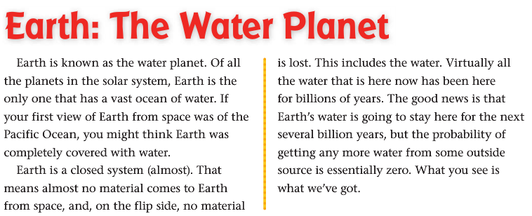

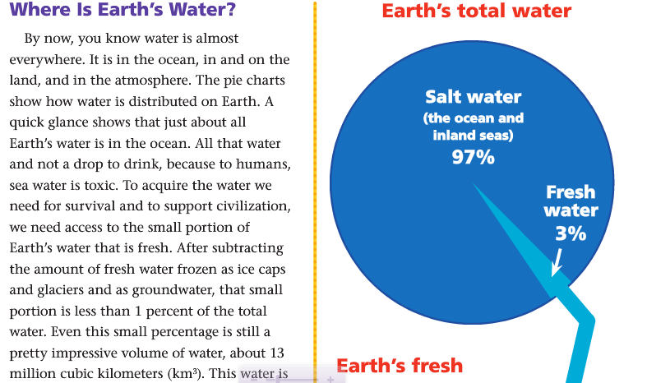
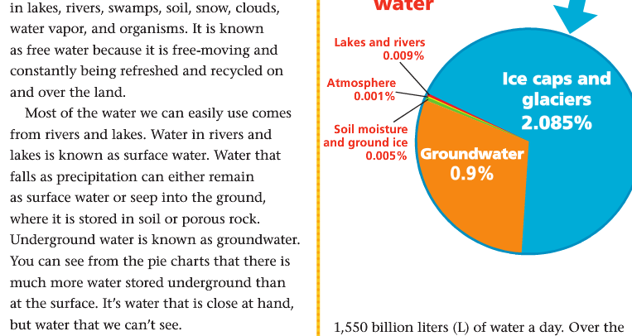
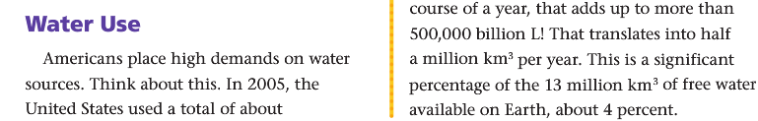
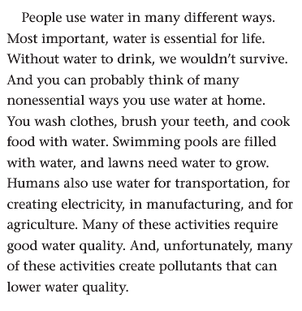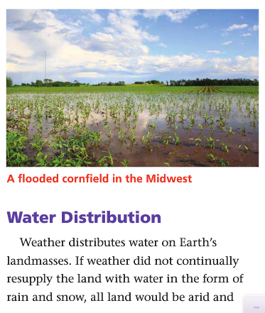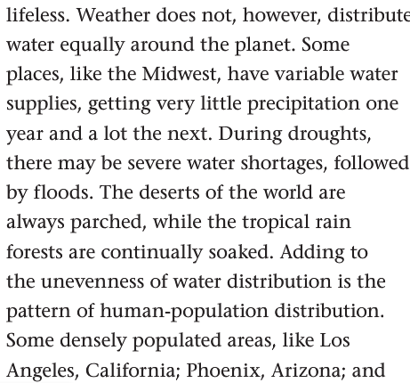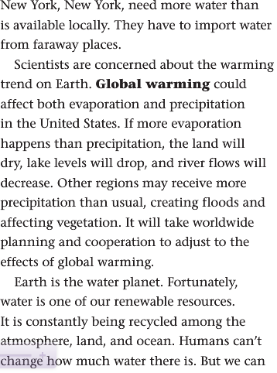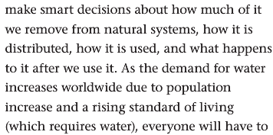
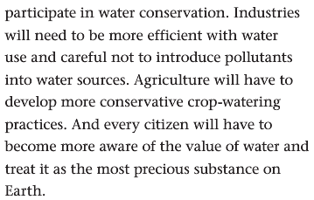
Answer the Think Questions on a separate sheet of paper in complete sentences.
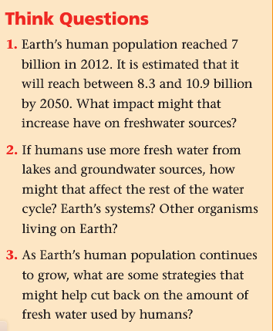
4) Why is Earth called “The Water Planet”?

