Name: ___________________________ Adv:______ 6/1/16
Homework
The Water Cycle

Use the clues and word bank on the next page to complete the crossword below. Each word is used only once and there are no extra words.

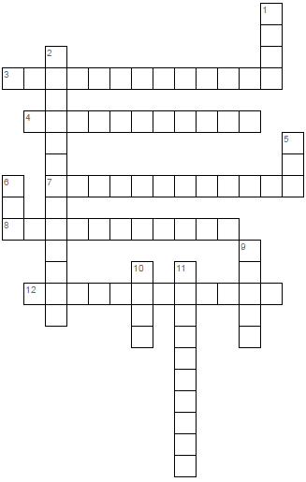

Word Bank:
Precipitation Evaporation Water Cycle
Rain Sun Sublimation
Desublimation Snow Ice
Infiltration Cloud Condensation

Clues:

