MATH Fluency PACKET
Order of Operations “DD”

Day | Homework Assignments
Monday  5/2/16 | Fluency – Order of Operations
Tuesday  5/3/16 | Fluency – Order of Operations
Wednesday  5/4/16 | Fluency – Order of Operations
Thursday  5/5/16 | Fluency – Order of Operations
Friday  5/6/16 | Fluency – Order of Operations

*Please be sure to SHOW ALL OF YOUR WORK!

FOR EXTRA HELP:
Visit the 6th grade website bvp2026.weebly.com OR call/text OR email us!
Mrs. S - (401) 871-0259 mhaynes@blackstonevalleyprep.org
Ms. Church - (401)500-3307 achurch@blackstonevalleyprep.org
Ms. Volpe - (401)871-8912 kvolpe@blackstonevalleyprep.org

This packet will be checked DAILY!

Fluency DD– Monday
SCORE: _____/10

Directions: Solve the problems below in 2 minutes or less. You MUST solve them in order, moving vertically. To reach mastery, you must to be able to correctly simplify at least 7 expressions using PEMDAS.
HW: ONCE THE TIMER STOPS, DRAW A STAR NEXT TO THE LAST PROBLEM YOU COMPLETED. THEN FINISH THE PAGE!

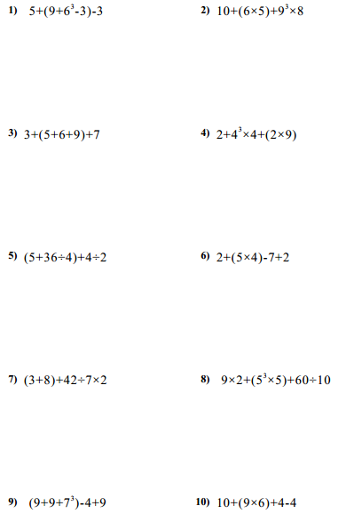

Fluency DD– Tuesday
SCORE: _____/10

Directions: Solve the problems below in 2 minutes or less. You MUST solve them in order, moving vertically. To reach mastery, you must to be able to correctly simplify at least 7 expressions using PEMDAS.
HW: ONCE THE TIMER STOPS, DRAW A STAR NEXT TO THE LAST PROBLEM YOU COMPLETED. THEN FINISH THE PAGE!

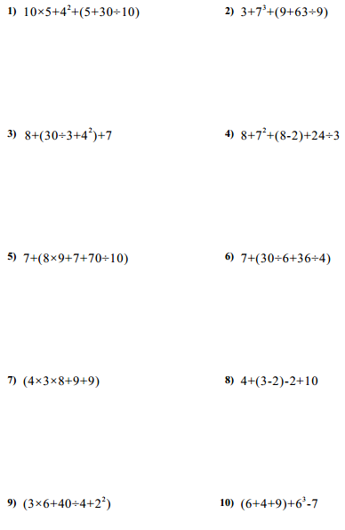

Fluency DD– Wednesday
SCORE: _____/10

Directions: Solve the problems below in 2 minutes or less. You MUST solve them in order, moving vertically. To reach mastery, you must to be able to correctly simplify at least 7 expressions using PEMDAS.
HW: ONCE THE TIMER STOPS, DRAW A STAR NEXT TO THE LAST PROBLEM YOU COMPLETED. THEN FINISH THE PAGE!

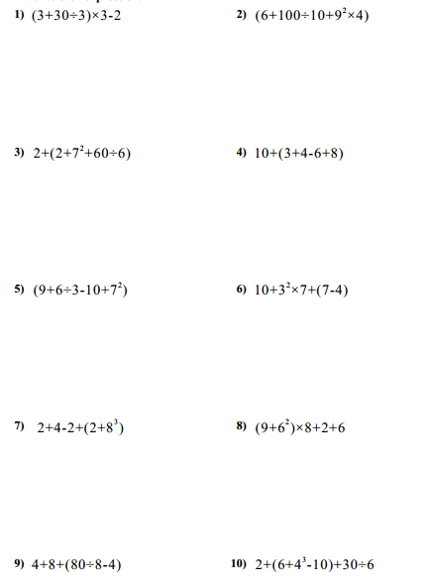

Fluency DD– Thursday
SCORE: _____/10

Directions: Solve the problems below in 2 minutes or less. You MUST solve them in order, moving vertically. To reach mastery, you must to be able to correctly simplify at least 7 expressions using PEMDAS.
HW: ONCE THE TIMER STOPS, DRAW A STAR NEXT TO THE LAST PROBLEM YOU COMPLETED. THEN FINISH THE PAGE!

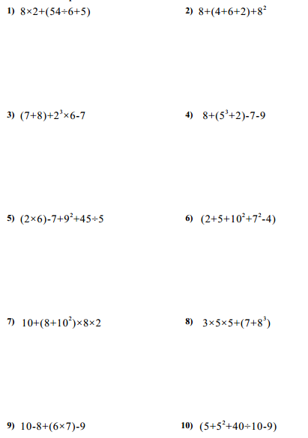

Fluency DD– Friday
SCORE: _____/10

Directions: Solve the problems below in 2 minutes or less. You MUST solve them in order, moving vertically. To reach mastery, you must to be able to correctly simplify at least 7 expressions using PEMDAS.
HW: ONCE THE TIMER STOPS, DRAW A STAR NEXT TO THE LAST PROBLEM YOU COMPLETED. THEN FINISH THE PAGE!
