MATH Fluency PACKET
GCF and LCM “EE”

Day | Homework Assignments
Tuesday  3/22/16 | Fluency – GCF and LCM
Wednesday  3/23/16 | Fluency – GCF and LCM
Thursday  3/24/16 | Fluency – GCF and LCM

*Please be sure to SHOW ALL OF YOUR WORK!

FOR EXTRA HELP:
Visit the 6th grade website bvp2026.weebly.com OR call/text OR email us!
Mrs. S - (401) 871-0259 mhaynes@blackstonevalleyprep.org
Ms. Church - (401)500-3307 achurch@blackstonevalleyprep.org
Ms. Volpe - (401)871-8912 kvolpe@blackstonevalleyprep.org

This packet will be checked DAILY!

Fluency EE – Monday
SCORE: _____/16

Directions: Solve the problems below in 2 minutes or less. You MUST solve them in order, moving vertically. To reach mastery, you must to be able to correctly find the GCF or LCM of at least 10 of the problems.
HW: ONCE THE TIMER STOPS, DRAW A STAR NEXT TO THE LAST PROBLEM YOU COMPLETED. THEN FINISH THE PAGE!

Find GCF | Find LCM
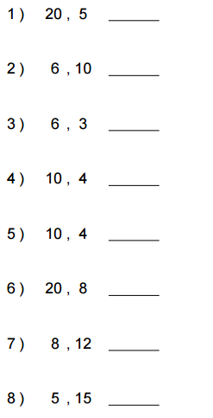 | 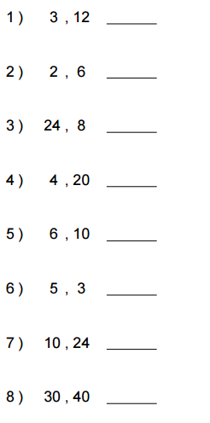

Fluency EE – Tuesday
SCORE: _____/16

Directions: Solve the problems below in 2 minutes or less. You MUST solve them in order, moving vertically. To reach mastery, you must to be able to correctly find the GCF or LCM of at least 10 of the problems.
HW: ONCE THE TIMER STOPS, DRAW A STAR NEXT TO THE LAST PROBLEM YOU COMPLETED. THEN FINISH THE PAGE!

Find GCF | Find LCM
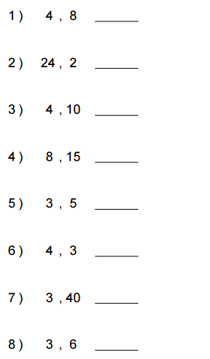 | 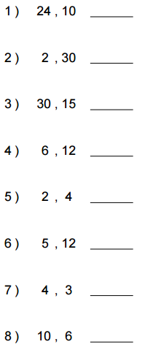

Fluency EE – Wednesday
SCORE: _____/16

Directions: Solve the problems below in 2 minutes or less. You MUST solve them in order, moving vertically. To reach mastery, you must to be able to correctly find the GCF or LCM of at least 10 of the problems.
HW: ONCE THE TIMER STOPS, DRAW A STAR NEXT TO THE LAST PROBLEM YOU COMPLETED. THEN FINISH THE PAGE!
Find GCF | Find LCM
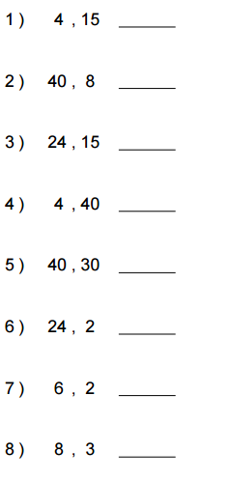 | 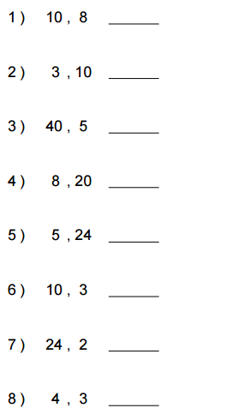

Fluency EE – Thursday
SCORE: _____/16

Directions: Solve the problems below in 2 minutes or less. You MUST solve them in order, moving vertically. To reach mastery, you must to be able to correctly find the GCF or LCM of at least 10 of the problems.
HW: ONCE THE TIMER STOPS, DRAW A STAR NEXT TO THE LAST PROBLEM YOU COMPLETED. THEN FINISH THE PAGE!
Find GCF | Find LCM
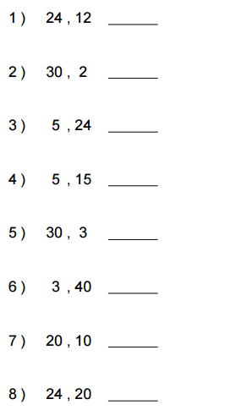 | 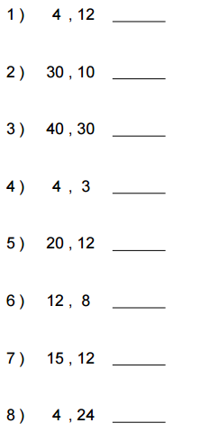

Fluency EE – Friday
SCORE: _____/16

Directions: Solve the problems below in 2 minutes or less. You MUST solve them in order, moving vertically. To reach mastery, you must to be able to correctly find the GCF or LCM of at least 10 of the problems.
HW: ONCE THE TIMER STOPS, DRAW A STAR NEXT TO THE LAST PROBLEM YOU COMPLETED. THEN FINISH THE PAGE!

Find GCF | Find LCM
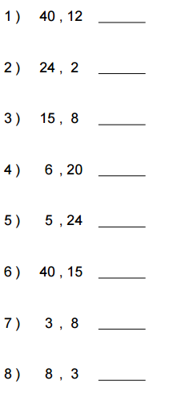 | 