MATH Fluency PACKET
Integer addition “FF”

Day | Homework Assignments
Monday  5/9/16 | Fluency – Integer addition
Tuesday  5/10/16 | Fluency – Integer addition
Wednesday  5/11/16 | Fluency – Integer addition
Thursday  5/12/16 | Fluency – Integer addition
Friday  5/13/16 | Fluency – Integer addition

*Please be sure to SHOW ALL OF YOUR WORK!

FOR EXTRA HELP:
Visit the 6th grade website bvp2026.weebly.com OR call/text OR email us!
Mrs. S - (401) 871-0259 mhaynes@blackstonevalleyprep.org
Ms. Church - (401)500-3307 achurch@blackstonevalleyprep.org
Ms. Volpe - (401)871-8912 kvolpe@blackstonevalleyprep.org

This packet will be checked DAILY!

Fluency FF – Monday
SCORE: _____/16

Directions: Solve the problems below in 1 minute or less. You MUST solve them in order, moving vertically. To reach mastery, you must to be able to correctly find the sum of at least 10 of the positive and negative numbers.
HW: ONCE THE TIMER STOPS, DRAW A STAR NEXT TO THE LAST PROBLEM YOU COMPLETED. THEN FINISH THE PAGE!

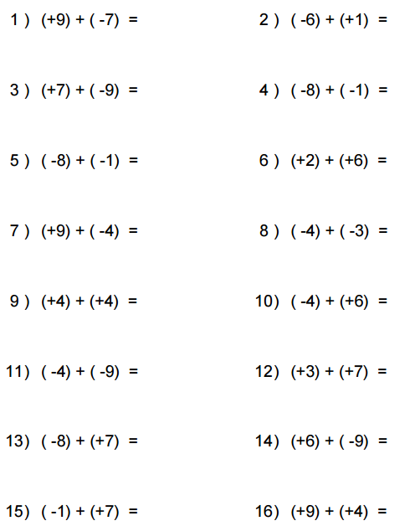

Fluency FF – Tuesday
SCORE: _____/16

Directions: Solve the problems below in 1 minute or less. You MUST solve them in order, moving vertically. To reach mastery, you must to be able to correctly find the sum of at least 10 of the positive and negative numbers.
HW: ONCE THE TIMER STOPS, DRAW A STAR NEXT TO THE LAST PROBLEM YOU COMPLETED. THEN FINISH THE PAGE!
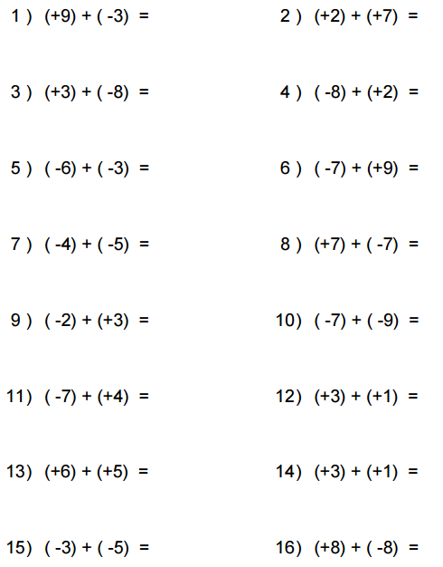

Fluency FF – Wednesday
SCORE: _____/16

Directions: Solve the problems below in 1 minute or less. You MUST solve them in order, moving vertically. To reach mastery, you must to be able to correctly find the sum of at least 10 of the positive and negative numbers.
HW: ONCE THE TIMER STOPS, DRAW A STAR NEXT TO THE LAST PROBLEM YOU COMPLETED. THEN FINISH THE PAGE!
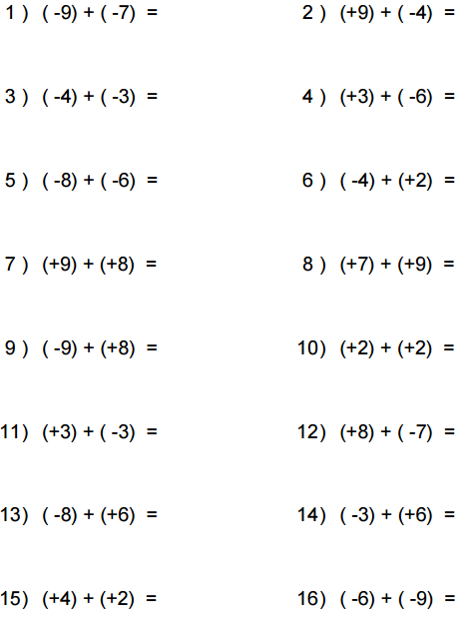

Fluency FF – Thursday
SCORE: _____/16

Directions: Solve the problems below in 1 minute or less. You MUST solve them in order, moving vertically. To reach mastery, you must to be able to correctly find the sum of at least 10 of the positive and negative numbers.
HW: ONCE THE TIMER STOPS, DRAW A STAR NEXT TO THE LAST PROBLEM YOU COMPLETED. THEN FINISH THE PAGE!
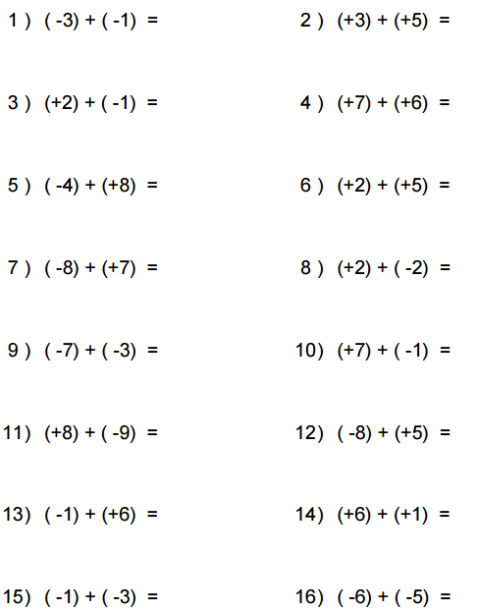

Fluency FF – Friday
SCORE: _____/16

Directions: Solve the problems below in 1 minute or less. You MUST solve them in order, moving vertically. To reach mastery, you must to be able to correctly find the sum of at least 10 of the positive and negative numbers.
HW: ONCE THE TIMER STOPS, DRAW A STAR NEXT TO THE LAST PROBLEM YOU COMPLETED. THEN FINISH THE PAGE!
