MATH Fluency PACKET
Fraction subtraction “LL”

Day | Homework Assignments
Monday  6/13/16 | Fluency – Fraction subtraction
Tuesday  6/14/16 | Fluency – Fraction subtraction
Wednesday  6/15/16 | Fluency – Fraction subtraction
Thursday  6/16/16 | Fluency – Fraction subtraction
Friday  6/17/16 | Fluency – Fraction subtraction

*Please be sure to SHOW ALL OF YOUR WORK!

FOR EXTRA HELP:
Visit the 6th grade website bvp2026.weebly.com OR call/text OR email us!
Mrs. S - (401) 871-0259 mhaynes@blackstonevalleyprep.org
Ms. Church - (401)500-3307 achurch@blackstonevalleyprep.org
Ms. Volpe - (401)871-8912 kvolpe@blackstonevalleyprep.org

This packet will be checked DAILY!

Fluency LL – Monday
SCORE: _____/10

Directions: Solve the problems below in 2 minutes or less. You MUST solve them in order, moving vertically. To reach mastery, you must to be able to correctly find the REDUCED DIFFERENCE of all 10 fractions.
HW: ONCE THE TIMER STOPS, DRAW A STAR NEXT TO THE LAST PROBLEM YOU COMPLETED. THEN FINISH THE PAGE!

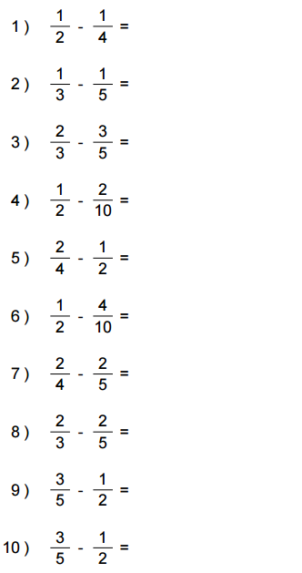

Fluency LL – Tuesday
SCORE: _____/10

Directions: Solve the problems below in 2 minutes or less. You MUST solve them in order, moving vertically. To reach mastery, you must to be able to correctly find the REDUCED DIFFERENCE of all 10 fractions.
HW: ONCE THE TIMER STOPS, DRAW A STAR NEXT TO THE LAST PROBLEM YOU COMPLETED. THEN FINISH THE PAGE!
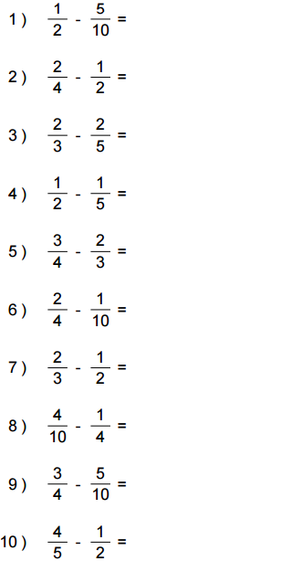

Fluency LL – Wednesday
SCORE: _____/10

Directions: Solve the problems below in 2 minutes or less. You MUST solve them in order, moving vertically. To reach mastery, you must to be able to correctly find the REDUCED DIFFERENCE of all 10 fractions.
HW: ONCE THE TIMER STOPS, DRAW A STAR NEXT TO THE LAST PROBLEM YOU COMPLETED. THEN FINISH THE PAGE!
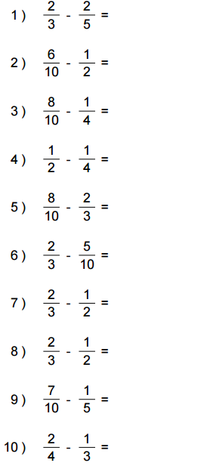

Fluency LL – Thursday
SCORE: _____/10

Directions: Solve the problems below in 2 minutes or less. You MUST solve them in order, moving vertically. To reach mastery, you must to be able to correctly find the REDUCED DIFFERENCE of all 10 fractions.
HW: ONCE THE TIMER STOPS, DRAW A STAR NEXT TO THE LAST PROBLEM YOU COMPLETED. THEN FINISH THE PAGE!

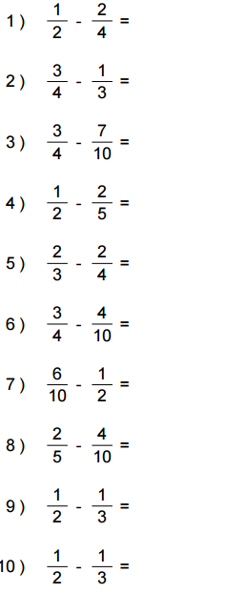

Fluency LL – Friday
SCORE: _____/10

Directions: Solve the problems below in 2 minutes or less. You MUST solve them in order, moving vertically. To reach mastery, you must to be able to correctly find the REDUCED DIFFERENCE of all 10 fractions.
HW: ONCE THE TIMER STOPS, DRAW A STAR NEXT TO THE LAST PROBLEM YOU COMPLETED. THEN FINISH THE PAGE!
