MATH Fluency PACKET
Multiply Fractions “W”

Day | Homework Assignments
Monday  4/4/16 | Fluency – Multiply Fractions
Tuesday  4/5/16 | Fluency – Multiply Fractions
Wednesday  4/6/16 | Fluency – Multiply Fractions
Thursday  4/7/16 | Fluency – Multiply Fractions
Friday  4/8/16 | Fluency – Multiply Fractions

*Please be sure to SHOW ALL OF YOUR WORK!

FOR EXTRA HELP:
Visit the 6th grade website bvp2026.weebly.com OR call/text OR email us!
Mrs. S - (401) 871-0259 mhaynes@blackstonevalleyprep.org
Ms. Church - (401)500-3307 achurch@blackstonevalleyprep.org
Ms. Volpe - (401)871-8912 kvolpe@blackstonevalleyprep.org

This packet will be checked DAILY!

Fluency W – Monday
SCORE: _____/15

Directions: Solve the problems below in 2 minutes or less. You MUST solve them in order, moving vertically. To reach mastery, you must to be able to correctly multiply at least 12 improper fractions.
HW: ONCE THE TIMER STOPS, DRAW A STAR NEXT TO THE LAST PROBLEM YOU COMPLETED. THEN FINISH THE PAGE!

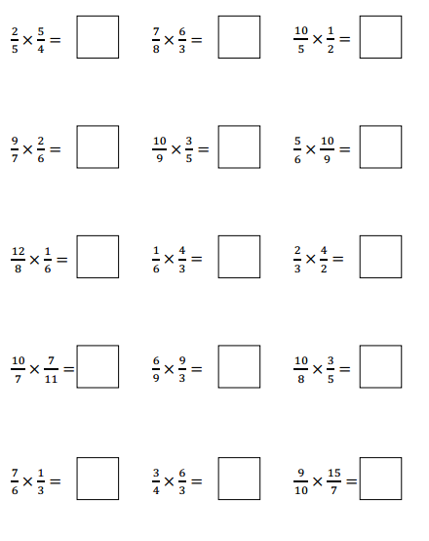

Fluency W – Tuesday
SCORE: _____/15

Directions: Solve the problems below in 2 minutes or less. You MUST solve them in order, moving vertically. To reach mastery, you must to be able to correctly multiply at least 12 improper fractions.
HW: ONCE THE TIMER STOPS, DRAW A STAR NEXT TO THE LAST PROBLEM YOU COMPLETED. THEN FINISH THE PAGE!

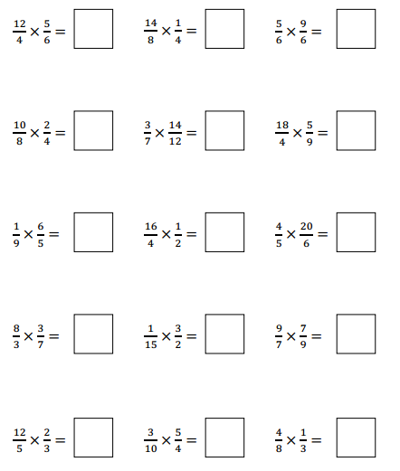

Fluency W – Wednesday
SCORE: _____/15

Directions: Solve the problems below in 2 minutes or less. You MUST solve them in order, moving vertically. To reach mastery, you must to be able to correctly multiply at least 12 improper fractions.
HW: ONCE THE TIMER STOPS, DRAW A STAR NEXT TO THE LAST PROBLEM YOU COMPLETED. THEN FINISH THE PAGE!
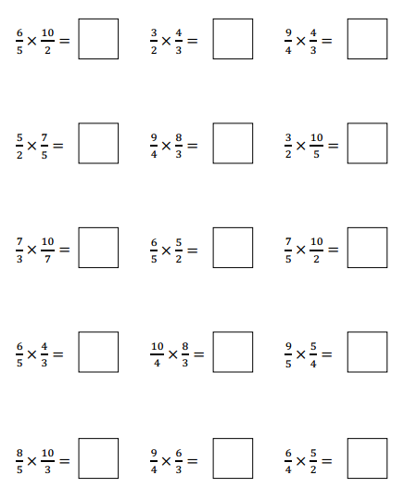

Fluency W – Thursday
SCORE: _____/15

Directions: Solve the problems below in 2 minutes or less. You MUST solve them in order, moving vertically. To reach mastery, you must to be able to correctly multiply at least 12 improper fractions.
HW: ONCE THE TIMER STOPS, DRAW A STAR NEXT TO THE LAST PROBLEM YOU COMPLETED. THEN FINISH THE PAGE!
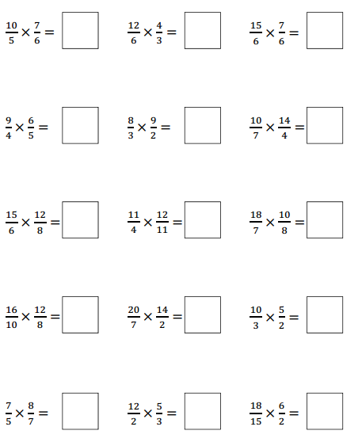

Fluency W – Friday
SCORE: _____/15

Directions: Solve the problems below in 2 minutes or less. You MUST solve them in order, moving vertically. To reach mastery, you must to be able to correctly multiply at least 12 improper fractions.
HW: ONCE THE TIMER STOPS, DRAW A STAR NEXT TO THE LAST PROBLEM YOU COMPLETED. THEN FINISH THE PAGE!

