Name: ________________________ Advisory: ____ 6.16.16
TRIMESTER 3 CTA Review

Vocabulary: Define the following vocabulary words.
weather:

climate:

salinity: _________________________________________________
_______________________________________________________
density:

density (equation):
troposphere:
solar angle:

humidity:

dew point:

evaporation:

condensation:

water vapor
_______________________________________________________

1) Create a model to demonstrate the difference between radiation, conduction, and convection.
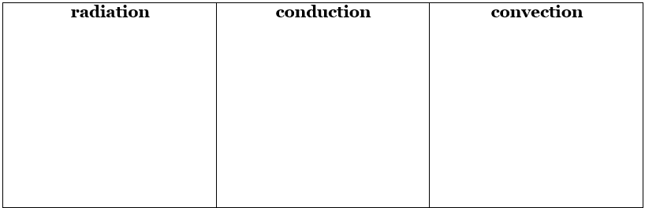2) What gas makes up most of the troposphere?
  - Which gas is second most common?
3) Describe how clouds form in the atmosphere.

4) What happens to the density of a gas when it is compressed?

___________________________________________________________
5) Draw a diagram that shows gases of two different densities.
Gas 1 | Gas 2
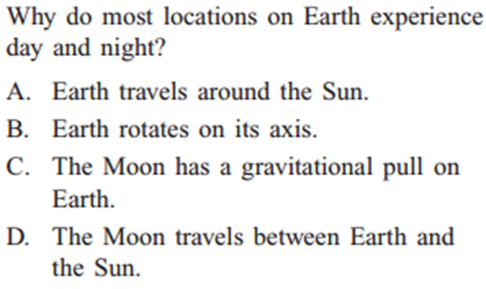
6) Circle the best answer.

7) You are a water molecule in the atmosphere. List two possible paths you could take. Explain how you move through that path.

Path 1:
Atmosphere __________________ __________________ …

Explanation: ____________________________________________________________

Path 2:
Atmosphere __________________ __________________ …

Explanation:
____________________________________________________________

8) Compare the two paths you created in #7 with the ‘traditional’ water-cycle model. ____________________________________________________________
________________________________________________________________________________________________________________________
9) Imagine a pressure map of the United States. There is an area of low pressure and an area of high pressure. Which direction is the wind blowing?
________________________________________________________________________________________________________________________
10) What is the relationship between solar angle and latitude? _________________
________________________________________________________________________________________________________________________

11) A student built the terrarium below to model the water cycle. What role in the water cycle do the plants in the terrarium play?

_________________________________
_________________________________
_________________________________
_________________________________
_________________________________
_________________________________

12) What is the relationship between latitude and climate? ____________________
________________________________________________________________________________________________________________________
13) What is the relationship between solar angle and climate? __________________
________________________________________________________________________________________________________________________

