Tri 3 Review Packet Answer Key
climate -the average or typical weather conditions in a region

condensation-the process by which water vapor changes into liquid water

density-the amount of mass in a material compared to its volume

density formula- Density equals mass divided by volume

dew point-the temperature at which air is saturated with water vapor and vapor condenses into liquid

evaporation- the process by which liquid water changes into water vapor

humidity – the amount of water vapor in the air

salinity-the amount of salt concentration

solar angle- the angle at which light from the Sun strikes the surface of Earth

troposphere- the layer of the atmosphere that begins at Earth’s surface and extends upward; where weather forms

water vapor- the gaseous state of water

weather- the condition of the atmosphere at a given location and time.

(your examples may vary)
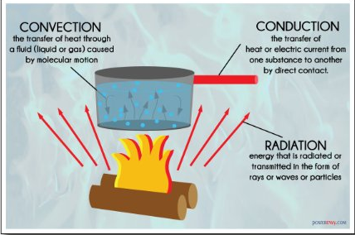
1)

2) Nitrogen gas makes up most of Earth’s troposphere
Oxygen is the second most common gas in Earth’s troposphere.

3) For a cloud to form there needs to be water vapor in the air, a cooling temperature, and a condensation nuclei. The temperature needs to drop to the Dew Point for the water vapor to condense on the condensation nuclei.

4) When a gas is compressed (squeezed into a smaller space) the density of the gas increases.

5)
Gas 1 (MORE dense) | Gas 2 (LESS dense)

6) B
7) Paths may vary. However, the path needs to be in order, one location must be directly related to the next. Examples below:
Atmosphere -> cloud-> rain
The water vapor condenses to form a cloud, then cools to fall to Earth
Atmosphere-> rain-> lake
The water vapor condenses and falls to Earth as rain, and is absorbed into a lake

8) The traditional water cycle shows one path. However, water isn’t only evaporated from the oceans it can evaporate and go into the atmosphere from many other different locations, like lakes, rivers, the ground, humans (as sweat), and many more! Also, water can be found in many other locations around Earth, including plants, animals, and the other locations listed above.

9) Winds are created by differences in air pressure. Air moves from areas of high pressure to areas of low pressure.

10) The lower the latitude (closer to the equator) the higher the solar angle. Areas of Earth at the equator receive more direct sunlight, the sunlight is concentrated at a smaller area.

11) The plants take in water from the soil and then release the water from their leaves into the atmosphere as water vapor.

12) The lower the latitude, the higher the temperatures and less precipitation.

13) The higher the solar angle, the higher the amount of direct sunlight causing the climate to be warmer and drier.
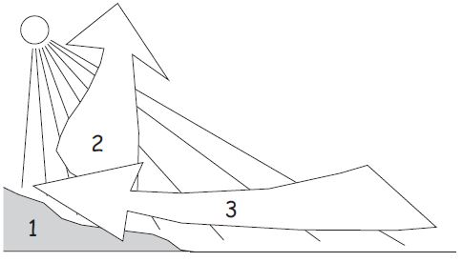
sea breeze
1) Earth’s surface doesn’t heat evenly. Land heats faster than ocean. 2) Warmer air over the land is less dense & rises, creating a low-pressure area. 3) Cooler, denser air over the water creates a high-pressure area. Wind blows from high pressure to low pressure

