Pre-Columbian Civilizations: Which Pre-Columbian civilization in the Americas was the most advanced?
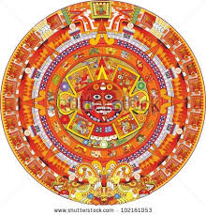

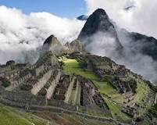
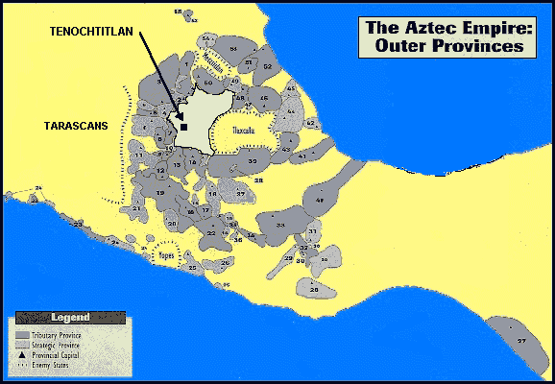

Overview: Aboriginal Native American cultures emerged in modern-day Meso America and the Andean region prior to the arrival of the Spanish Conquistadors in the 15th and 16th Centuries CE. The three main Pre-Columbian civilizations (Aztecs, Mayans, and Incans) built vast empires and civilizations that rivaled the achievements of the early civilizations of Egypt and Mesopotamia. Their intellectual and technical mastery in many areas has intrigued and amazed those who have studied them. This Mini-Q asks you to examine these civilizations and decide which civilization is the most advanced.
The Documents:
- Document A: Mayan Mathematics
- Document B: Mayan Kukulcan Pyramid
- Document C: Mayan Calendar
- Document D: Aztec Empire: Outer Provinces
- Document E: Aztec City of Tenochtitlan
- Document F: Aztec Farming
- Document G: Incan Road System
- Document H: Incan recording (The Quipu)
- Document I: Incan Farming (Potato Cultivation)
Hook Exercise: What makes a civilization “advanced”?
Directions: The word “advanced” is fuzzy when it is used as a measuring stick for a civilization. What do we mean when we say that an achievement or civilization is “advanced”? What exactly would go into classifying a civilization “advanced”?
Task One: Below is a list the five characteristics of a group of people being classified as an advanced civilization. Next to each characteristic are four criteria for judging this “advancement”. Your job is to select those one or two criteria that best explain why each characteristic would be used to classify a group of people as being an advanced civilization.
Criteria:
- Scale = Size
- Genius = Brilliance; cutting-edge thinking
- Effort = Physical or mental
- Significance = Impact on a society or the world
Characteristic | Scale | Genius | Effort | Significance
Record Keeping
Specialized Jobs
Advanced Cities
Advanced Tools
Complex Institutions

Task Two: Of the five characteristics listed above, which is the best indicator of a civilization being “most” advanced? Be able to defend your answer in terms of the four listed criteria.
Background Essay:
Which Pre-Columbian American civilization was the most “advanced”?
History is rich with stories of great human achievement. Consider the Egyptians, who built the pyramids; the Greeks, who invented and practiced democracy and philosophy; the Chinese, who conceived and constructed the Great wall. In the Western Hemisphere, several early cultures developed remarkable advancements that went undiscovered by the known world until the accidental discovery of the Americas in the late 15th Century CE. This discovery ends the era in American history known as the Pre-Columbian era.
The Pre-Columbia era incorporates all historical time between the ending of the last Ice Age (roughly 10,000 BCE) and the discovery of the American continents by the Europeans in the late 15th Century CE. While this era includes hundreds of cultures and civilizations, the Pre-Columbian era in Mesoamerica (modern-day Mexico and Central America) and South America typically includes the big 3 civilizations of the Maya, Aztec, and Inca. Many of these Pre-Columbian civilizations established hallmarks which included permanent or urban settlements, agriculture, civic and monumental architecture, major earthworks, and complex societal hierarchies. Some of these civilizations had long faded by the time of the first permanent European arrivals, and are known only through archeological investigations, but others, such as the Maya, Aztec, and Inca, were still in existence and personally experienced by the Spanish conquistadors of the 15th and 16th Century CE.
The Big 3 civilizations dominated their respected regions successfully for centuries but were no match for the technological and biological destruction capabilities of their European conquerors. While much of the history of these advanced ancient civilizations were destroyed by their Christian European conquerors, several documents, descriptions, pictures, and ruins still exist for our examination today.
What follows are several documents showing Aztec, Mayan, and Incan accomplishments. To measure these accomplishments, and to help make your thinking more precise, pay special attention to the following four criteria for judging the “advancement” of these cultures:
- Scale: how big was the accomplishment/advancement?
- Genius: how brilliant or cutting-edge was the accomplishment/advancement?
- Effort: how hard physically or intellectually was the accomplishment/advancement?
- Significance: what was the accomplishment/advancement’s impact on society?
Using the criteria above, answer the question posed by this Mini-Q: Which Pre-Columbian civilization was the most advanced?
Background Essay Questions: Using the background essay and extended research, answer the following questions.
- Where was the civilization you chose located?
- How was this civilization organized politically?
- What rituals did this civilization use to please their gods?
- What happened to this civilization after the arrival of the Europeans?
- In what way does this civilization’s culture still exist?
- Define these civilization characteristics with regard to the civilization you chose:
  - Advanced Cities-
  - System of record keeping-
  - Specialized Jobs-
  - Complex institutions-
  - Advanced technology-

Timeline of Major Pre-Columbian Civilizations
1200 BCE – Olmec Civilization (Mother Culture of Mesoamerica) Begins
400 BCE – Olmec Civilization Ends/Declines
500 CE – Tikal becomes a major Mayan city
800-1200 CE – Major Mayan Decline
900 CE – Chichen Itza building mostly completed (Mayan city)
1200 CE – Incans build city of Cuzco (capital)
1325 CE – Rise of the Aztec Civilization
1493 CE – Incan empire reaches its height in South America
1517 CE – Hernando Cortez arrives in Mexico
1521 CE – Fall of the Aztecs
1532 CE – Francisco Pizarro arrives in South America
1572 CE – Last Incan emperor executed; end of the Incan Empire
Understanding the Question and Pre-Bucketing
Understanding the Question:
- What is the analytical question asked by this Mini-Q?
- What terms in the question need to be defined?
- Rewrite the question in your own words.
Pre-Bucketing
Directions: Using any clues from the Mini-Q question and the document titles on the cover page, think of possible analytical categories and label the buckets. We suggest either a two- or a four- bucket format.

OR
Document 1: Mayan Mathematics
Instead of 10 digits like we have today, the Maya used a base number of 20 with only 3 symbols. They used a system of bars and dots as "shorthand" for counting. A dot stood for one and a bar stood for five.

In the following table, you can see how this works.
0 | 1 | 2 | 3 | 4
5 | 6 | 7 | 8 | 9
10 | 11 | 12 | 13 | 14
15 | 16 | 17 | 18 | 19
Because the base of the number system was 20, larger numbers (ones above 20) were written in a series of rows using powers of 20. In the Maya system, each row was multiplied by 20 (see examples below). The advantage of using this system was that the Mayans only needed 3 symbols (one for 0, one for 1, and one for 5). Numbers were written from bottom to top. Below you can see how the number 32 was written:

20's  2nd line = # x 20 | (1x20)
1's  1st line = #s 1-19 | (12)

It was very easy to add and subtract using this number system. Here's an example of a simple addition:
4th line = # x 20 x 20 x 20 |  | + |  | =
3rd line = # x 20 x 20 |  | + |  | =
2nd line = # x 20 |  | + |  | =
1st line = #s 1-19 |  | + |  | =
 | 9449 | + | 10425 | = | 19874
*Analyze the complexity of this system and explain how this system was advanced and benefitted the Mayans.
Document 2: Mayan Cities
Archeologists have argued that civilization requires urban centers and that the measure of a civilization can be made by the architecture of its cities. Based on its architectural remains, Mayan civilization ranks as one of the great pre-industrial cultures of the world.
By 1975, archaeologists had catalogued more than 2,500 Mayan locations of varying size and date with some stone construction. Numerous cities with populations in the tens of thousands have left a monumental record in the Pre-Columbian era.
Masonry architecture required central organization, craft specialization, and political power to command a large workforce. The Maya were able to organize the labor of masons, plasterers, and supervising architects to build and maintain their cities of immense stone pyramids, stone palaces and temples, ball courts, and other ritual buildings. For the single home of a Copan nobleman (Mayan city of about 25,000 people), it has been estimated that at least 80-130 workers would have been employed fulltime to finish it in two to three months. The densest urban core of a city such as Tikal (one of the largest Mayan cities, with a population of 70,000), covered six square miles, so the number of workers in construction and reconstruction must have been immense.
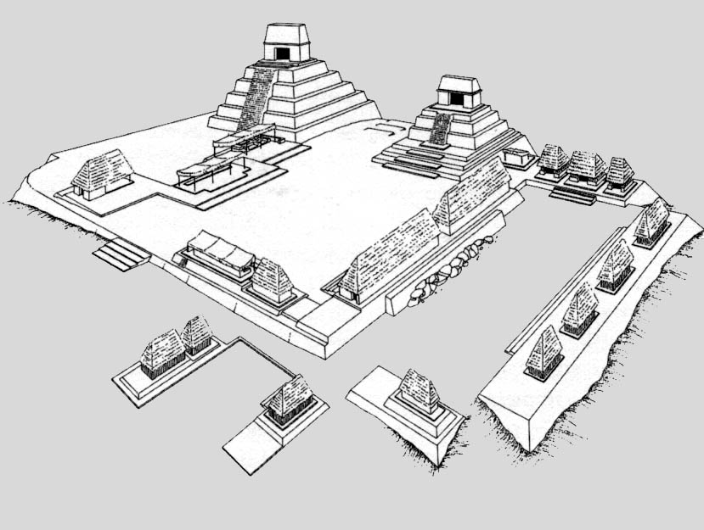
Questions:
- What evidence does a Mayan city show of an organized government?
- Why would the architecture shown be an example of high education and architectural experience? What does this experience tell you about their society?
- Research more information about the design and significance of Mayan architecture and explain how that information shows a sophisticated/advanced society.
Document 3: The Mayan Calendar
The Maya had two main calendars. One was the sacred or ritual calendar, called tzolkin. It was a cycle of 260 days, and it marked the ceremonial life of the people. They also had a civil calendar, based on the solar year. This calendar had eighteen months of twenty days each; adding up to 260 days in all. To this were added five unlucky days; called Uayeb, to make a total of 365 days as in our calendar. This solar calendar was called haab. The two calendar cyclers were used together. They were like two cogged wheels (gears), revolving alongside each other, with the cogs (days) meshing as the wheels turned.
The Maya developed the calendar further than any other New World people, and their calendar was more accurate than any other calendar of their time. They were masters of the science of time measurement. Observatories were built, at Chichen Itza and other cities, to use in studying the movements of the sun and the moon, planets such as Venus and Mars, and the stars. The Mayan priest-astronomers collected information over many years in order to make their predictions and develop their systems. So great was their knowledge that they could predict eclipses of the moon.
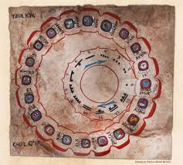
Questions:
- What does this calendar system tell you about the educational level of the Mayan people?
- What does it tell you about the Mayan culture that most other Mesoamerican societies adopted and used the Mayan calendar?
- Why did the Mayan calendar have “unlucky days”? What does it tell you about their understanding of the solar system that they had these?
Document 4: The Aztec Empire
Below is a map of the Aztec Empire. The darker areas are the Tributary Provinces. These areas, listed in the Codex Mendoz tribute roll, made regularly scheduled tribute payments to the imperial capitals in the Valley of Mexico. The lighter numbered zones are Strategic Provinces. The towns in these areas were exempt from regular tribute payments, but they were responsible for maintaining the imperial frontiers against such enemies as the Tarascans, Yopes, and Tlaxcala. The identification of these two types of imperial provinces is one of the major advances of the Aztec Imperial Strategies.

Questions
- Define the following: province, tribute, imperialism
- What does this organization tell you about the structure and sophistication of the Aztec Empire?
- Why would this organization be considered advanced and advantageous?
Document 5: Cortes’ Description of Tenochtitlan
Hernando Cortés was a Spanish explorer and conquistador who landed on the coast of Mexico in 1519. Learning of the powerful Aztec empire and its capital city of Tenochtitlan, Cortés traveled over one hundred miles inland to find the city and claim the Empire for Spain. At the time, the city of Tenochtitlan was home to over 100,000 people and one of the largest cities in the world. In August 1521, the Spanish and their Native American allies defeated the Aztecs and conquered the city. The Spanish leveled Tenochtitlan and built Mexico City on the site of the Aztec capital. Primary sources, such as the accounts written by Hernando Cortés and other Spanish officials, are the only surviving writings we have of this once great city.
"This great city of Tenochtitlan is built on the salt lake, and no matter by what road you travel there are two leagues from the main body of the city to the mainland. There are four artificial causeways leading to it, and each is as wide as two cavalry lances. The city itself is as big as Seville or Córdoba. The main streets are very wide and very straight; some of these are on the land, but the rest and all the smaller ones are half on land, half canals where they paddle their canoes. All the streets have openings in places so that the water may pass from one canal to another. Over all these openings and some of them are very wide, there are bridges. . . . There are, in all districts of this great city, many temples or houses for their idols. They are all very beautiful buildings. . . . Amongst these temples there is one, the principal one, whose great size and magnificence no human tongue could describe, for it is so large that within the precincts, which are surrounded by very high wall, a town of some five hundred inhabitants could easily be built. All round inside this wall there are very elegant quarters with very large rooms and corridors where their priests live. There are as many as forty towers, all of which are so high that in the case of the largest there are fifty steps leading up to the main part of it and the most important of these towers is higher than that of the cathedral of Seville. . . ."
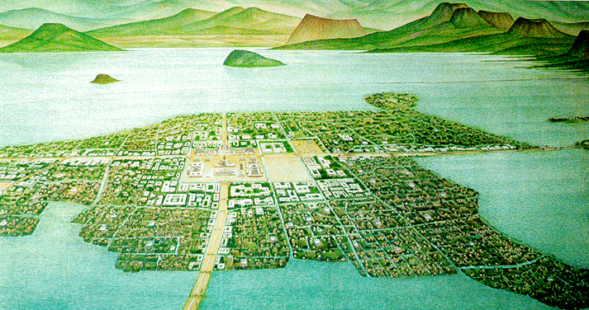
1. What are some of the objects and structures that Cortés sees in Tenochtitlan?
2. What does this primary source tell you about the city? What does Cortés' account tell you about the Aztec people?
3. What technology does Cortés mention in his account that shows the Aztecs were able to adapt to this environment?
Document 6: Aztec Farming
By 1519, when the first Spanish conquistadors under Hernán Cortés landed in Mexico, the Aztecs were in control of an empire that was inhabited by a population of 5 to 6 million people. This large population meant that the exploitation of the landscape for agricultural purposes had to be intensified. This can be seen in the use of the chinampa agricultural system, the so-called ‘floating gardens’ which can be found on the shallow lake beds in the Valley of Mexico. A chinampa plot was constructed by staking out a rectangular enclosure, about 30 m in length and 2.5 m in width, into the marshy lakebed. The enclosure would then be fenced in by joining the stakes with wattle. After that, the fenced in area would be filled with mud and decaying vegetation. In order to prevent the roots from becoming water-logged, it was important that the fill brought the chinampa plot above the lake level. While constructing the next plot, which would be parallel to the first, a narrow canal for the passage of canoe would be left in between these two chinampa plots. The canals surrounding the chinampa plots formed an illusion that these agricultural lands were floating on water, hence its misattribution as ‘floating gardens’. To further stabilize these plots of land, willows were planted around the perimeter. This is due to the dense root system which, over time, anchored the retaining walls of the structure and reduced the effects of erosion. Chinampas, when properly completed, could produce up to 7 yields of crops per year, allowing the Aztecs to feed their people with dramatically less farmland than other societies.
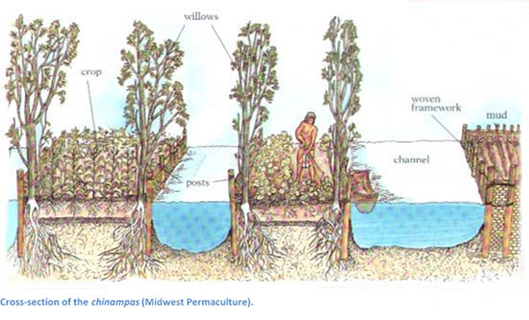
Questions:
- Why is the construction and design of the chinampa considered to be advanced?
- How would the creation of the chinampa system have benefitted the Aztecs (at least 2 ways)?
Document 7: The Incan Road System
The Incan Road System was the most extensive and advanced transportation system in pre-Columbian South America. The construction of the roads required a large expenditure of time and effort, and the quality of that construction is shown by the fact that it is still in quite good condition after 400 years of use. The network was based on two north-south roads with numerous branches that stretched to a total of approximately 25,000 miles of total road. The best known portion of the road system is the Incan Trail to Machu Pichu that includes thousands of miles of road and dozens of sophisticated bridges. Part of the road network was built by cultures that precede the Incan Empire, notably the Wari Culture. During the Spanish colonial era, parts of the road system were given the status of Camino Real (The Royal Road).
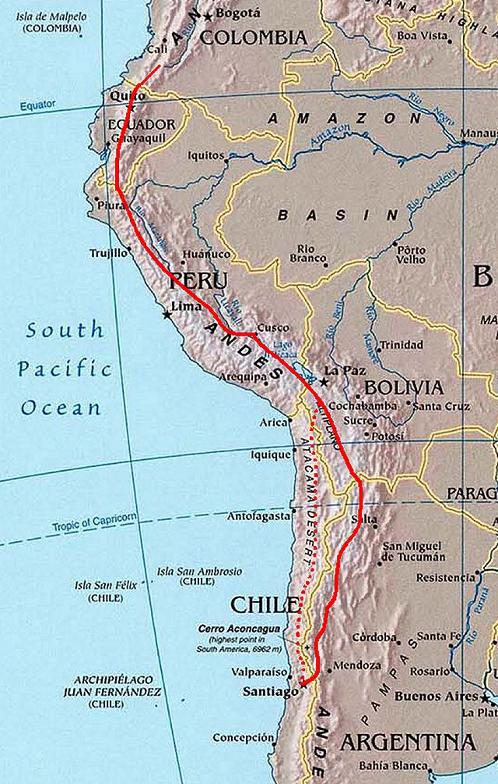
Answer the following questions:
- How many miles was this road system?
- What information from the paragraphs above tells you that these roads were extremely advanced?
- What about the geography of the Incan Empire makes the building of these roads even more incredible?
Document 8: The Quipu
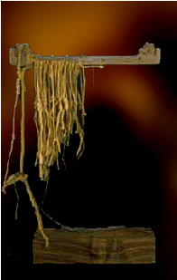
According to their position, the knots signified units, tens, hundreds, thousands, ten thousands and, exceptionally, hundred thousands, and they were all as well aligned on their different cords as the figures that an accountant sets down, column by column, in his ledger. Indeed, those men, called quipucamayus, who were in charge of the quipus, were exactly that, imperial accountants.
The number of quipucamayus scattered throughout the Empire, was proportional to the size of each place. Thus the smallest villages numbered four, and others twenty, or even thirty. The Incas preferred this arrangement. Even in places where one accountant would have sufficed, the idea being that, if several of them kept the same accounts, there was less risk that they would make mistakes.
Every year, an inventory of all the Inca’s possessions was made. Nor was there a single birth or death, a single departure or return of a soldier, in all the Empire, which was not noted on the quipus. And indeed, it may be said that everything that could be counted, was counted in this way, even to battles, diplomatic missions, and royal speeches. But since it was only possible to record numbers in this manner, and not words, the quipucamayus assigned to record ambassadorial missions and speeches, learned them by heart, at the same time that they noted down the numbers, places and dates on their quipus; and thus, from father to son, they transmitted this information to their successors. The speeches exchanged between the Incas and their vassals on important occasions, such as the surrender of a new province, were also transmitted to posterity by the amautas, or philosophers, who summarized them in simple, clear fables, in order that they might be implanted by word of mouth in the memories of all the people from those at court to the inhabitants of the most remote hamlets. The harauicus, or poets, also composed poems based on diplomatic records and royal speeches. These poems were recited for a great victory or festival, and every time a new Inca was knighted.
After reading the description above, answer the following questions:
- What does this knot system tell you about the intelligence/advancement of the Incas?
- Why would they need such a sophisticated counting system? What does it tell you about their empire that they felt they needed it?
- What about the geography of the region might require a system like this instead of a written recording system?
Document 9: Machu Picchu
Embedded within a dramatic landscape at the meeting point between the Peruvian Andes and the Amazon Basin, the Historic Sanctuary of Machu Picchu is among the greatest artistic, architectural and land use achievements anywhere and the most significant tangible legacy of the Inca civilization. Recognized for outstanding cultural and natural values, the property covers 32,592 hectares of mountain slopes, peaks and valleys surrounding its heart, the spectacular archaeological monument of “La Ciudadela” (the Citadel) at more than 2,400 meters above sea level. Built in the fifteenth century Machu Picchu was abandoned when the Inca Empire was conquered by the Spaniards in the sixteenth century. It was not until 1911 that the archaeological complex was made known to the outside world.
The approximately 200 structures making up this outstanding religious, ceremonial, astronomical and agricultural centre are set on a steep ridge, crisscrossed by stone terraces. Following a rigorous plan the city is divided into a lower and upper part, separating the farming from residential areas, with a large square between the two. To this day, many of Machu Picchu’s mysteries remain unresolved, including the exact role it may have played in the Incas’ sophisticated understanding of astronomy and domestication of wild plant species, but it has been discovered that the agricultural areas could not have fully supported the population essentially showing that a sophisticated system of the transport of goods.
Questions:
- What does the location and layout of the city of Machu Picchu tell you about the architectural ability of the Incas?
- Historians believe this was used as a religious camp and not a permanent city. What does this and the fact that food would need to be shipped in (even if the servants/royal family were only staying for the season) tell you about the Incan society?
Bucketing – Getting Ready to Write
Bucketing
Look over all the documents and organize them into your final buckets. Use either a two- or a four- bucket format. Write bucket labels under each bucket and place the letters of the documents in the buckets where they belong. Remember, your buckets are going to become your body paragraphs.

OR

Thesis Development and Road Map
On the chicken foot below, write your thesis and your road map. Your thesis is always an opinion and answers the Mini-Q question. The road map is created from your bucket labels and lists the topic areas you will examine in order to prove your thesis.

OR

Mini-Q Student Lined Paper for Rough Draft Outlining:
_______________________________________________________________________________________________________________________________________________________________________________________________________________________________________________________________________________________________________________________________________________________________________________________________________________________________________________________________________________________________________________________________________________________________________________________________________________________________________________________________________________________________________________________________________________________________________________________________________________________________________________________________________________________________________________________________________________________________________________________________________________________________________________________________________________________________________________________________________________________________________________________________________________________________________________________________________________________________________________________________________________________________________________________________________________________________________________________________________________________________________________________________________________________________________________________________________________________________________________________________________________________________________________________________________________________________________________________________________________________________________________________________________________________________________________________________________________________________________________________________________________________
From Thesis to Essay Writing
Mini-Q Essay Outline Guide: You must use this outline sheet prior to starting your rough draft in order to receive full credit!!!!
Working Title: -________________________________________________________________ _____________________________________________________________________________
Paragraph #1 (Intro):
Grabber: _____________________________________________________________________ _____________________________________________________________________________
Background: (Stating the question with key terms defined)_____________________________ _______________________________________________________________________________________________________________________________________________________________________________________________________________________________________
Thesis Statement: ______________________________________________________________ __________________________________________________________________________________________________________________________________________________________
Paragraph #2 (Evidence #1 backing up thesis):
Baby Thesis for bucket 1: ________________________________________________________ _____________________________________________________________________________
Evidence of achievements: (Supporting detail from documents WITH document citation: _____ __________________________________________________________________________________________________________________________________________________________
Argument for achievements: (Using criteria to explain “Why Advanced”): _________________ ____________________________________________________________________________________________________________________________________________________________________________________________________________________________________________________________________________________________________________________
Conclusion Sentence: (Wrap up paragraph #2): ______________________________________ _____________________________________________________________________________
Paragraph #3 (Evidence #1 backing up thesis):
Baby Thesis for bucket 1: ________________________________________________________ _____________________________________________________________________________
Evidence of achievements: (Supporting detail from documents WITH document citation: _____ __________________________________________________________________________________________________________________________________________________________
Argument for achievements: (Using criteria to explain “Why Advanced”): _________________ ____________________________________________________________________________________________________________________________________________________________________________________________________________________________________________________________________________________________________________________
Conclusion Sentence: (Wrap up paragraph #2): ______________________________________ _____________________________________________________________________________
Paragraph #4 (Evidence #1 backing up thesis):
Baby Thesis for bucket 1: ________________________________________________________ _____________________________________________________________________________
Evidence of achievements: (Supporting detail from documents WITH document citation: _____ __________________________________________________________________________________________________________________________________________________________
Argument for achievements: (Using criteria to explain “Why Advanced”): _________________ ____________________________________________________________________________________________________________________________________________________________________________________________________________________________________________________________________________________________________________________
Conclusion Sentence: (Wrap up paragraph #2): ______________________________________ _____________________________________________________________________________
Paragraph #5 (Conclusion)
Restate Thesis and Evidence used: _________________________________________________ _____________________________________________________________________________

